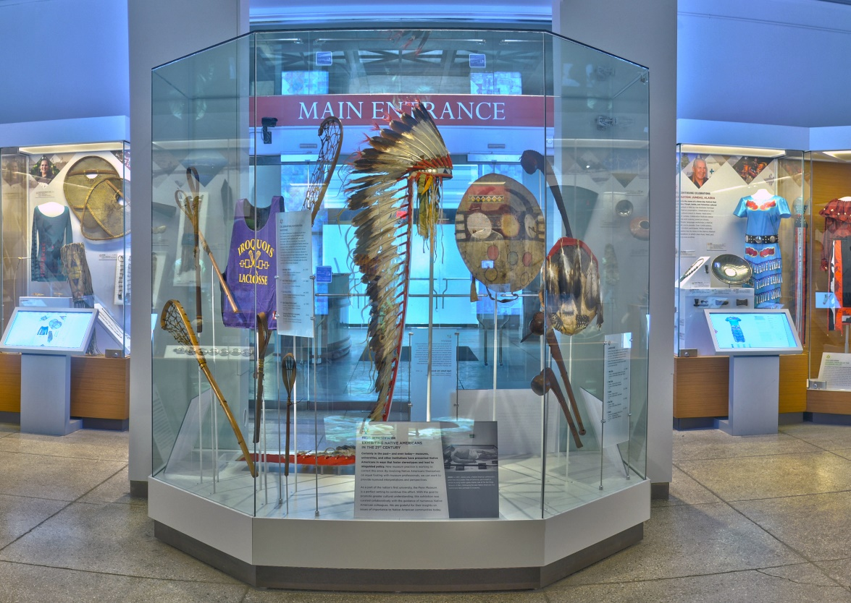 |  | An Artifact is Worth a Thousand Words
African, Native American, Etruscan, and Egyptian Galleries |  | 50 minutes

Items in the galleries can often be great inspiration for stories. In fact, an archaeological expedition was the inspiration for one of Agatha Christie’s novel, Murder in Mesopotamia. There is a plethora of items throughout the galleries that can be used to inspire students and get their creative juices flowing. Whether it be a ghost story about mummies, or a valiant warrior from the Mediterranean, artifacts in the galleries are sure to inspire!

Vocabulary List

- Characters: mummies, pharaoh, king, queen, priest, servant, child, warrior, god, goddess, dog, cat, ghost
- Items: tomb, sarcophagus, crown, jewelry (necklace, bracelet, earrings), statue, vase, villa, clothing, mask, temple
- Materials: stone, thread, bead, cloth, wood, metal, glass, ceramic, gold, silver, feather

The Museum Visit

Explore (5 minutes)
Give the class a few minutes to explore the exhibit.
Group Brainstorming (10-15 minutes)
Gather students around a central piece in the gallery and open up the conversation by discussing the object and possible story ideas. Encourage group dialogue, raising questions such as what the object is made of, why it might have been worn, what its physical qualities are, or what kind of story it might feature in.

Partner/Small Group Narratives (10-15 minutes)
Have students break into partners or small groups and explore the gallery, selecting an object or two to act as key elements of their story. Students should work together to devise a short narrative surrounding this object that they will later share with the rest of the class.

Storytelling and Conclusion (10 minutes)
Gather students at the center of the gallery and invite one representative from each group to relate their story in front of the key artifact.

recommended objects

African Gallery
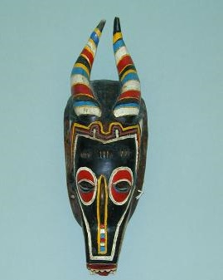

Mask (95-22-1)

Dance Crest (82-1-1)

Kifwebe Mask (AF1881)

Native American Voices
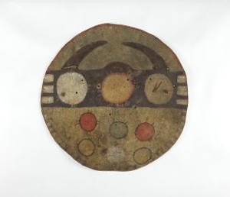

Shield (NA5595)

War Club (45-15-1110)

War Bonnet (31-23-142)

recommended objects

Egypt

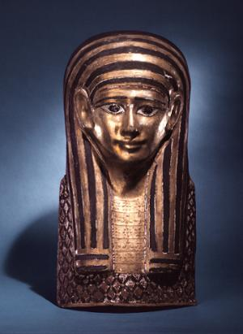

Mummy Mask (53-20-1A)

Sarcophagus Lid (E16135A)

Mummy Case (E14344B)

Statue of Pharaoh (E635)

Etruscan Italy

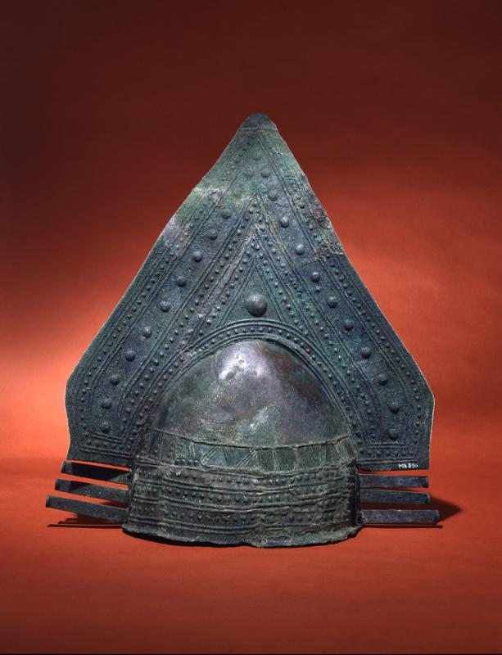

Crested Helmet (MS850)

Bronze Sheild (MS2728)

Bronze Cuirass (MS851)

Post-Visit Activities

Things That Go Bump in the Night
Individually or in pairs, students will write a ghost/scary story based on 2-3 objects that they discovered in the galleries.

Comic Strip
Create a one-page comic strip featuring 1-2 objects from the gallery. The students should include speech bubbles and/or captions to help clarify the narrative and action.

Questions?
Ready to schedule a visit?
Contact Penn Museum’s Academic Engagement Department at
classuse@pennmuseum.org

